**Network Settings**

**■ GPRS network mode**

1. Long press the "M" key for 2 seconds to enter the "Configure the Network" mode.
2. In this mode, press "-" to set to "GPRS Network Mode" (please insert the SIM card to use).
3. After the setting is complete, restart the speaker and the network mode setting is successful.

**■ WIFI network mode set by Android**

1. Install MFApLink-1.2.1-release.apk(path: MF-XDK_ET\tools\WIFI setting), and accept all the permission requirements of this APK.
2. Long press the "M" key for 2 seconds to enter the "Configure Network Mode". In this mode, press "+" to set to “WIFI Network Mode”and enter WIFI configuration.

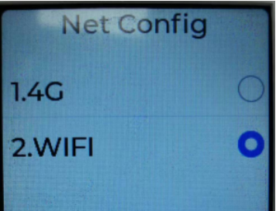

1. The mobile phone connect to the wifi which to be configured(only support 2.4GHz, not support 5GHz) .
2. Run MFApLink-1.2.1-release.apk, click “CONNECT”botton, input the correct password of the connected WIFI for configuration and make sure it is connected to the same WIFI as your phone. Click “CONNECT” button to continue.

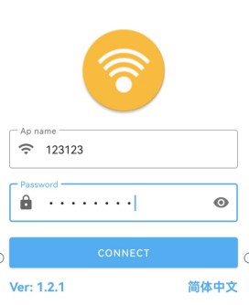

1. In “Search device list”, find the corresponding AP name(the AP name is usually device sn or Default device).Select corresponding AP name and click “CONFIRM” button.Click Connect in the pop-up prompt box.

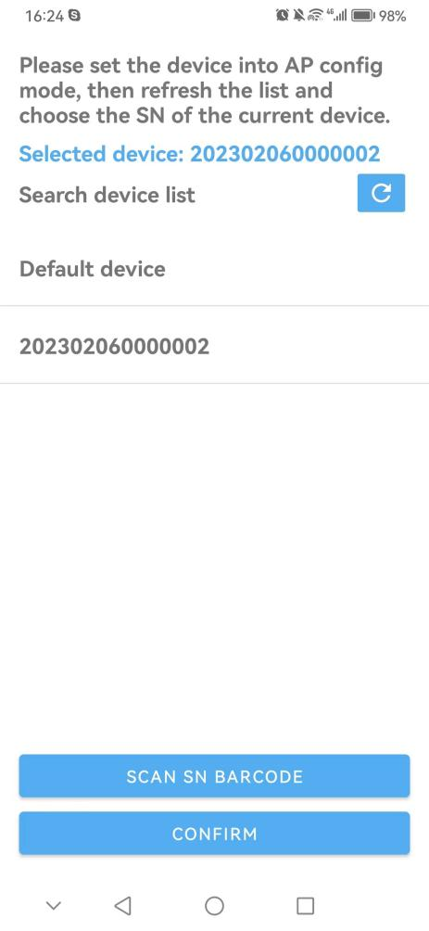

1. When APK prompts "AP link success!", it indicates that the the WIFI configuration is complete.Wait for the device to restart and confirm the WiFi network status.

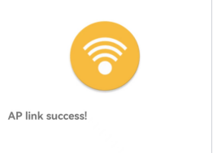

**■ WIFI network mode set by IOS**

1. Search “MFAPLink” in Apple AppStore and download to the IPhone.
2. Long press the "M" key for 2 seconds to enter the "Configure Network Mode". In this mode, press "+" to set to “WIFI Network Mode”and enter WIFI configuration.



1. Make sure your IPhone connected to a strong wifi signal. Open the MFAPLink app,you can see two mode showing on the screen.

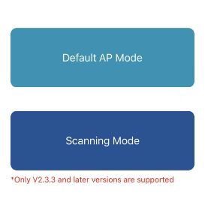

1. Choose Default AP Mode

a.Allow MFAPLink to use your location, input the wifi and password you Iphone is connecting,and click connect. Then click Join when it asked as below.

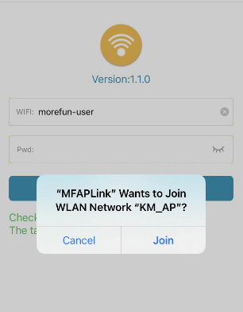

b.When the app shows below status,it means the wifi connection is success. The device will say “configure successfully” and reboot. Then you can check the network status.

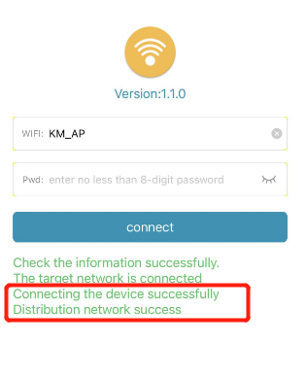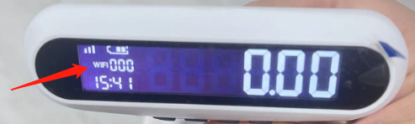

1. Scanning Mode

a.Make sure the machine enter WIFI configuration. Make sure your IPhone connected to a strong wifi signal. Choose Scanning Mode,and scan the bar code of the label on the back of the machine.

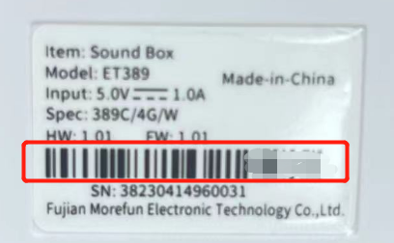

b.Enter the wifi and password your Iphone is connecting,click connect. When the app shows status in red box,it means the wifi connection is success. The device will say “configure successfully” and reboot. Then you can check the network status.

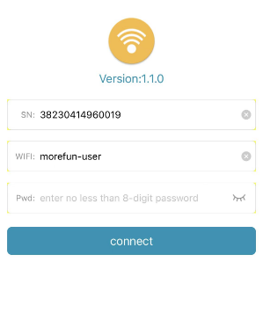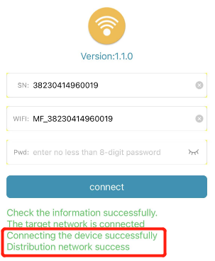

Notice:Only the system version V2.3.3 and later version, Wifi version V5.1.2 and later versions are support the Scanning Mode to configure wifi. Both are needed.

The system version V2.3.3 and before version, Wifi version V5.1.2 and before versions are support the Default AP Mode to configure wifi.Either is needed.

Refer to the “open&close log guidance” document to get below version information.

